1.

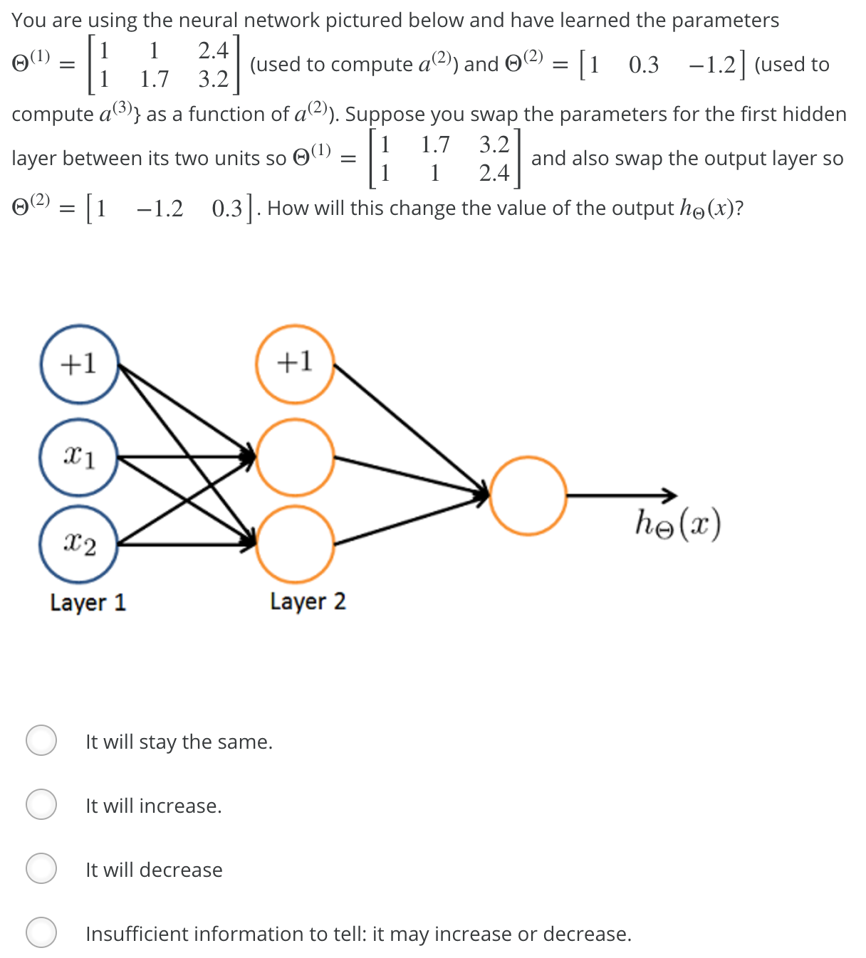

1. It will stay the same
2. It will increase
3. It will decrease
4. Insufficient information to tell, it may increase or decrease

2. Identify the following activation function :

φ(V) = Z + (1/ 1 + exp (– x * V + Y) ), Z, X, Y are parameters

1. Step Function
2. Ramp Function
3. Sigmoid function
4. Gaussian Function

3.In training a neural network, you notice that the loss does not decrease in the few starting epochs.

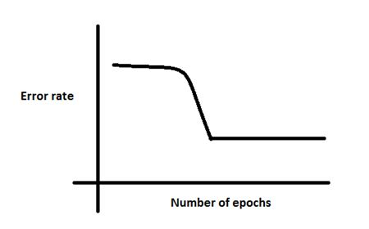

The reasons for this could be:

1. The learning is rate is low
2. Regularization parameter is high
3. Stuck at local minima

What according to you are the probable reasons?

a) 1 and 2

b) 2 and 3

c) 1 and 3

d) Any of these

4. Batch Normalization is helpful because

a) It normalizes (changes) all the input before sending it to the next layer

b) It returns back the normalized mean and standard deviation of weights

c) It is a very efficient backpropagation technique

d) None of these

5.The activation values of the hidden units in a neural network, with the sigmoid activation function applied at every layer, are always in the range (0, 1). (True/False)

Ans. True

6. An artificial neuron receives n inputs x1, x2, x3............xn with weights w1, w2, ..........wn attached to the input links. The weighted sum_________________ is computed to be passed on to a non-linear filter Φ called activation function to release the output.

1. Σ wi
2. Σ xi
3. Σ wi + Σ xi
4. Σ wi* xi

7.Below is a mathematical representation of a neuron.

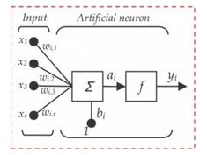

The different components of the neurons are denoted as:

1. x1, x2,…, xN: These are inputs to the neuron. These can either be the actual observations from input layer or an intermediate value from one of the hidden layers.
2. 2w1, w2,…,wN: The Weight of each input.
3. bi: Is termed as Bias units. These are constant values added to the input of the activation function corresponding to each weight. It works similar to an intercept term.
4. a: Is termed as the activation of the neuron

5. y: is the output of the neuron

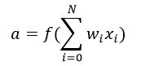

Considering the above notations, will a line equation (y = mx + c) fall into the category of a neuron?

a) Yes

b) No

8.Consider the scenario. The problem you are trying to solve has a small amount of data. Fortunately, you have a pre-trained neural network that was trained on a similar problem. Which of the following methodologies would you choose to make use of this pre-trained network?

a) Re-train the model for the new dataset

b) Assess on every layer how the model performs and only select a few of them

c) Fine tune the last couple of layers only

d) Freeze all the layers except the last, re-train the last layer

9.Y = ax^2 + bx + c (polynomial equation of degree 2)

Can this equation be represented by a neural network of single hidden layer with linear threshold?

a. Yes

b. No

10. Suppose you have a multi-class classification problem with three classes, trained with a 3 layer network. Let a(3)1=(hΘ(x))1 be the activation of the first output unit, and similarly a(3)2=(hΘ(x))2 and a(3)3=(hΘ(x))3. Then for any input x, it must be the case that a(3)1+a(3)2+a(3)3=1. (True/False) [ Explain your choice ]

Ans : False. The outputs of a neural network are not probabilities, so their sum need not be 1.

|  |
| --- |
|  |

11.A 4-input neuron has weights 1, 2, 3 and 4. The transfer function is linear with the constant of proportionality being equal to 2. The inputs are 4, 10, 5 and 20 respectively. The output will be:

a) 238

b) 76

c) 119

12.Suppose you have inputs as x, y, and z with values -2, 5, and -4 respectively. You have a neuron ‘q’ and neuron ‘f’ with functions:

q = x + y

f = q * z

Graphical representation of the functions is as follows:

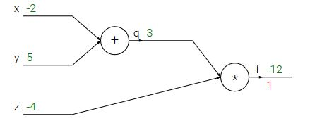

What is the gradient of F with respect to x, y, and z?

(HINT: To calculate gradient, you must find (df/dx), (df/dy) and (df/dz))

a. (-3,4,4)

b. (4,4,3)

c. (-4,-4,3)

d. (3,-4,-4)

13. You are experimenting with two different models for a classification task. The figures below show the classification error you get as training progresses on the training data and the validation data for each of the two models. Which model do you think would perform better on previously unseen test data?

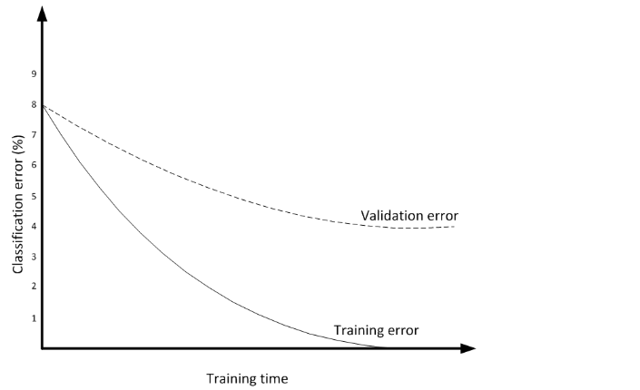

**2.**

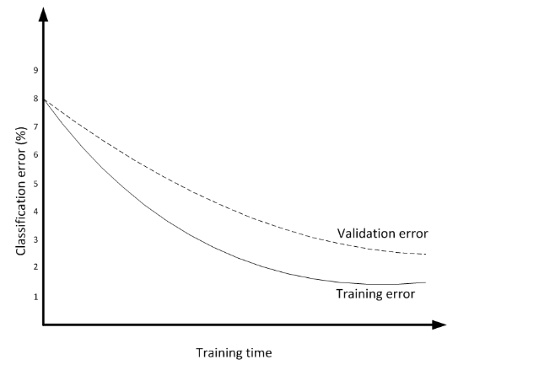

1. Only 1
2. Only 2
3. Both

14. What is delta (error) in the perceptron model of a neuron?

a) error due to environmental condition

b) difference between desired & target output

c) can be both due to the difference in target output or environmental condition

d) none of the mentioned

15. Which neural network model is computationally expensive

1. Back Propagation
2. LVQ
3. ART
4. Recurrent Back Propagation

16. A neuron with 3 inputs has the weight vector [0.2 -0.1 0.1]^T and a bias θ = 0. If the input vector is X = [0.2 0.4 0.2]^T then the total input to the neuron is:

1. 0.2
2. 10.0
3. 0.02
4. -1.